Big Ideas in Number Focus Area: **Partitioning**

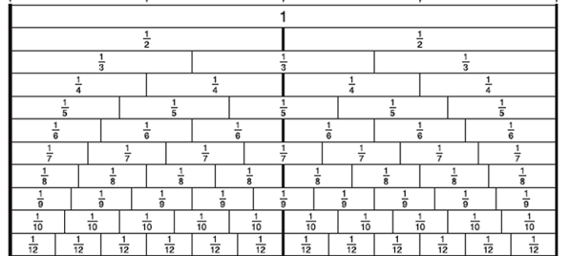

Name of Game or Activity: **Fraction Field**

Instructions:

Roll two 12 sided dice (dice depends on the fraction you are investigating) to produce a fraction e.g rolling a 2 and a 5 will make 2/5. The fraction is then coloured in on the fraction field. If the fraction cannot be made an equivalent fraction or added fraction can be used e.g. 4/10 for 2/5 or 1/5 + 2/10. The aim of the game is to be the first to fill the Fraction Field.

Resources:

* Two 12 sided dice
* Fractions field

**BIiN Micro Content**

|  |  |
| --- | --- |
| **Objects, quantities and collections can be shared to create equal parts** |  |
| **There is a relationship between the number of parts and the size and name of the parts and the number of parts increases as the size or share decreases** |  |
| **Objects, quantities and collections can be repeatedly halved and doubled e.g. use successive splits to show that one half is equivalent to 2 parts in 4, 4 parts in 8 etc.** |  |
| **An object, quantity or collection can be partitioned into a number of equal portions to show unit fractions so that say one third is more than one fourth etc.** |  |
| **The relative magnitude of a fraction is dependent on the relationship between the numerator (how many parts) and the denominator (total parts)** |  |
| **Fractions are renamed as equivalents where the total number of parts (denominator) and required number of parts (numerator) are increased by the same factor** |  |
| **Fractions with unlike denominators can be compared and ordered** |  |
| **Common fractions and decimal fractions can be compared, ordered and renamed in conceptual ways** |  |
| **Construct of fraction as division can be used to produce equal parts (equipartitioning)** |  |
| **Fractions are used to describe quotients and operators** |  |
| **Fractions are used to describe part-whole relations** |  |
| **Fractions are used to describe simple ratios** |  |
| **Percentages, fractions and decimals express the relationship between to quantities** |  |
| **Percentages are special part : whole ratios based on 100** |  |
| **Any given percentage can be used as a ratio to generate an infinite number of equivalent fractions (e.g. 50% = ½ 2/4 3/6 etc.)** |  |
| **Multiplicative arrays can be used to represent fractions, decimals and percentages** |  |
| **Benchmark fractions, decimals and percentages which are the equivalents of one another, can be used to estimate and to solve problems** |  |

